Hardware and Software

L.O.: To be able to identify and give examples of each category of software

|  |  |
| --- | --- |
| **Internal Components** | **External Components** |
| CPU | Monitor |
| RAM | Keyboard |
| GPU | Mouse |
| Network Card | Printer |

# Software

**Software** is a general term used to describe all the programs we run on our computer.

* **Application software** is programs that the user uses to complete a task
* **System software** covers a range of programs concerned with setting up and running the computer
* **Utility programs** are software that

*e.g. chkdsk (checks for corruptions); defrag (defragments storage drives)*

* **Library programs** carry out common tasks such as file maintenance and can be built into other programs

*e.g. imageres.dll (retrieves default system icons); netshell.dll (provides access to network interfaces)*

# Operating System

The **Operating System** provides a platform in which other software can run. It also provides methods for said software to interact with hardware devices.

|  |  |  |
| --- | --- | --- |
| **General Purpose** | **Special Purpose** | **Bespoke** |
| Have a variety of uses, e.g.:  - Microsoft Word  - Microsoft Excel | Have one core purpose, e.g.:  - Web Browser  - Accounts package  - Audio recording | Tailor made for a specific company / client |
| Relatively cheap (off the shelf) | Cost depends on application web browser ships free, but accounts packages can be expensive | Expensive because development cost is meet by just one client rather than spread across millions of users (as is the case for general purpose software) |

|  |  |  |
| --- | --- | --- |
| **Compilers** | **Interpreters** | **Assemblers** |
| Convert a whole program into machine code to be executed. | Read, convert, and execute one line of a program at a time. Translate the source code at run-time (not before like a Compiler). | Convert assembly language code into machine code and execute it. |
| Code is compiled and packaged into executable files before a program is available to its users. | Useful to debug small sections of code without having to compile an entire project. | Used when coding in Assembly code which is a ‘Low Level Language’ |

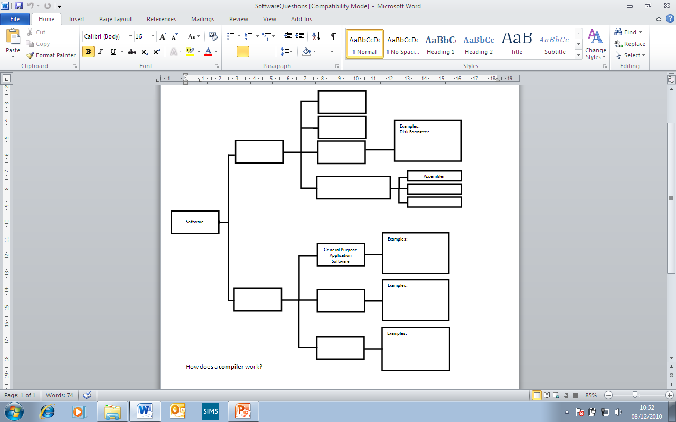

System

Software

Application

Software

Bespoke

Applications

Special-Purpose

Applications

Microsoft Word

Web Browser

BeamFusion

Operating

System

Library

Programs

Utility

Programs

Programming Language

Translators

Compiler

Interpreter